COMP3000 – Project Portfolio

Computing Project

2022/2023

Audio Authentication via Voice Recognition on QTrobot (AAVR)

Gregory Kua Wee Leng

10687413

BSc (Hons) Computer Science (Cyber Security)



# 1 Acknowledgement

I would like to thank my supervisor Dr Hai-Van Dang for all the support and help that has been given to me over the course of this project. The time that she has spent with me to help me improve upon the work I have done is invaluable.

I would also like to thank my friends and family for being supportive of me during this time. They have been really helpful during my lows and I appreciate them.

# 2 Abstract

Word Count:

Repository: https://github.com/greatyarn/COMP3000_Computing_Project

Contents

1 Acknowledgement 1

2 Abstract 1

3 Links 4

4 Introduction 4

4.1 Project Vision 4

4.2 Background / Scene Setting 4

4.2.1 Regarding project changes 4

4.2.2 Infrastructure of the QTrobot 0

4.2.3 Poster 1

4.3 Market Research 2

4.3.1 HSBC Banking 2

4.3.2 Google Assistant 2

4.3.3 Windows 10 / 11 2

4.4 User Stories / Aims and Objectives 2

4.6 Legal, Social, Ethical & Professional Issues 2

4.6.1 Legal Issue 2

4.6.2 Social Issue 4

4.6.3 Ethical Issue 4

4.6.4 Professional Issue 4

4.7 Meeting Minutes 4

5 Project Management 4

5.1 Gantt Chart / Sprint Plannings 5

5.2 Kanban Board 5

5.3 Version Control 6

6 Project Methodology and Implementation 7

6.1 Project Design / SHOW EARLY DESIGNS OF THE PROJECT BEFORE 7

6.2 Skills in Implementation 8

6.3 Deviation in Original Planning in regards to Gantt Chart 8

6.2 Project Testing 8

6.2.1 User Testing 8

6.2.2 Developer Testing 8

7 Sprint Reviews 9

7.1 Sprint 0 9

7.2 Sprint 1 10

7.3 Sprint 2 10

7.4 Sprint 3 11

7.5 Sprint 4 12

7.6 Sprint 5 13

7.7 Sprint 6 14

7.8 Sprint 7 15

7.9 Sprint 8 15

7.10 Sprint 9 16

7.11 Sprint 10 17

7.12 Sprint 11 17

7 Critical Evaluation 17

8 Evaluation (Discussion of Deviation, Big Changes) 17

8.1 Sprints Evaluation 17

8.2 Post Evaluation 17

9 Reflection 17

10 Conclusion 17

11 References 18

12 Appendix 19

12.1 Licensing for external libraries 19

# 3 Links

|  |  |
| --- | --- |
| **Document Reference** | **Online Links** |
| Gantt Chart | [High Res Image (Imgur)](https://i.imgur.com/RVbzxjV.png), [(Mirror)](https://files.catbox.moe/5wyc0n.png) |
| Trello Board | [Trello](https://trello.com/invite/b/stCxAKF8/bacc4ca9cf8aefa46403a2451d15e98f/comp3000computingproject) |
| Version Control | [GitHub](https://github.com/greatyarn/COMP3000_Computing_Project) |
| Meeting Minutes | [OneDrive](https://liveplymouthac-my.sharepoint.com/:w:/g/personal/gregory_kua_students_plymouth_ac_uk/ET_B3DV5e4NFkSzo-IntXoQB-lrf6EN-2o3SvNtGJFMPZQ?e=sp2L0p) |
| Linux GUI Issue | [High Res Image (Imgur)](https://imgur.com/a/XXE2ADH) ([Mirror](https://files.catbox.moe/wo4iak.zip)) |
| Flowchart Maker and Diagram Software | [Draw.io](draw.io/) |
| Gantt Chart Software | [GanttProject](https://www.ganttproject.biz/) |
| Operating System for QTrobot | [Ubuntu](https://ubuntu.com/) |
| Poster & Thumbnail | [Poster (Imgur)](https://i.imgur.com/j2SajIp.jpg) ([Mirror](https://files.catbox.moe/bs75wv.jpg)), [Thumbnail](https://i.imgur.com/HJI9um1.jpg) ([Mirror](https://files.catbox.moe/4psejv.jpg)) |

# 4 Introduction

## 4.1 Project Vision

*The QTrobot is a toddler-like humanoid robot built by LuxAI. This project, Audio Authentication via Voice Recognition on QTrobot, or AAVR for short, is a software for patients who would like to allow for an easy way to authenticate themselves through robots with the use of their voice. This authentication process with the use of a human voice allows for patients to retrieve their medical records, which might contain their age, height, and weight. This method of authenticating by voice is safer and more convenient as it reduces the amount of human interaction that is needed, therefore allowing for an improvement of personal data security as a whole. With voice authentication, this allows for multiple different patient profiles to be set up conveniently.*

## 4.2 Background / Scene Setting

This project is done in conjunction with the PRIDE (Privacy-preserving Robotics in DEntistry). It is an initiative between dentistry, robotics and cyber security (*Privacy-preserving Robotics in DEntistry (PRiDE), n.d.*). This project is part of a wider program that stems and involves with students and lecturers across the world. It is meant to be used in the world of dentistry. Patients are allowed to communicate with the Qtrobot directly instead of going to a counter. This allows easier access for people who have problem with socialising with others but who still needs to get healthcare access.

This project allows a user or a patient to identify to the Qtrobot to allow to authenticate themselves. It uses an OTP (One time password) authentication method with an email address to allow for the user to proof that they are in the system. The OTP will be sent to the patient’s email address and they will be able to speak the code out. The code will then be checked against the code that was sent out. If the code is correct, the user will be able to hear the next part of what they can do within the health centre.

### 4.2.1 Regarding project changes

This section is just to explain that within the course of this project’s timeline, there have been changes to the direction of this project. Mainly, when this project first started out, it was meant to have voice recognition in built to recognise different profiles when a user speaks to it but due to some circumstances that will be explained in the Project Methodology and Implementation section this project steered towards speech recognition instead while making use of user’s personal detail to authenticate themselves other means.

### 4.2.2 Infrastructure of the QTrobot

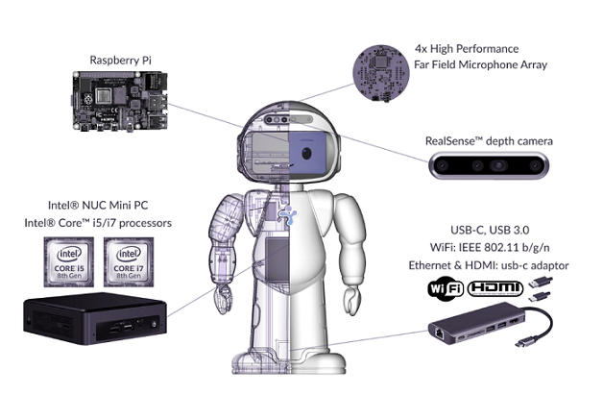

The QTrobot is an autism robot tutor for improving a child’s learning outcome at home (QTrobot, 2022). The robot is made of a raspberry pi, 4x microphones, a depth camera powered by Intel’s RealSense and a Nuc (*QTrobot documentation, n.d.*). The camera that is in the robot is connected to the Intel Nuc. The USB C adapter that is provided is also connected to the Nuc. The raspberry pi connects the rest of the components together. The Raspberry Pi links to the Nuc via an internal LAN (Local Area Network) cable. Each device, the nuc and the raspberry pi has been setup with different IP addresses. This component consists of the display that is on the face opf the robot, the speakers and microphone. There is also another usb at the back of the robot to plug in to the Raspberry Pi directly.

The QTRobot in the current configuration for this report is done via wifi through the Raspberry Pi. The Raspberry Pi passes the internet connection that is received through the LAN cable which is in the robot internally. This is how both the Raspberry Pi and the NUC can get an internet connection through one network.

### 4.2.3 Poster

There are two images that are shown below. The two images are the thumbnail and the poster itself. Both images were made within Photoshop. Assets that were used are publicly available on their respective websites. This poster was made for the showcase that will happen after the submission of this portfolio. The thumbnail and poster will also be uploaded on the university’s website if need be. Both of the high-resolution images can be found here.

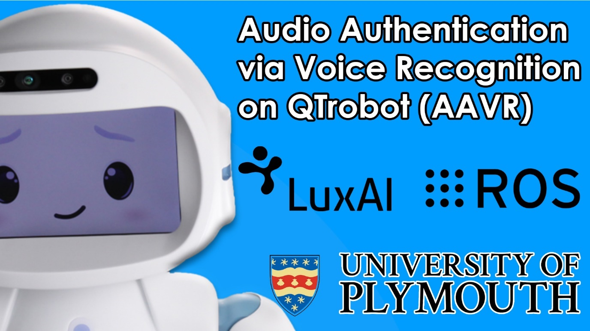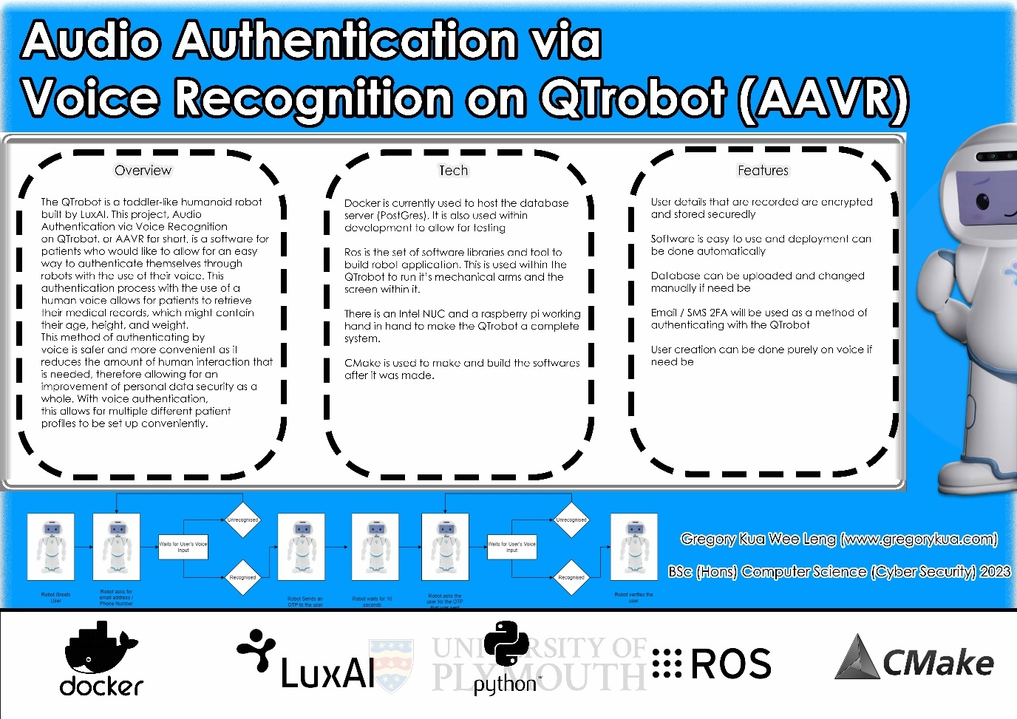

## 4.3 Market Research

Market research is done to see if there is any relevant services or providers that have done similar projects to what this project is doing. The following below are the market research that have been done early in the project’s planning phase.

### 4.3.1 HSBC Banking

[HSBC UK](https://www.hsbc.co.uk/ways-to-bank/phone-banking/) developed a new voice-driven technology back in 2020. When one calls the support help line on their mobile phone. The user would be instructed to repeat a sentence which is “My Voice is my password”. This allows HSBC to do a check whether if the user calling is the person that owns the bank account (HSBC, n.d.).

### 4.3.2 Google Assistant

[Google Assistant](https://support.google.com/assistant/answer/9071681#vm_pr&zippy=%2Cvoice-match-personal-results) has a feature called Voice Match. Voice Match allows users of Google Devices to let their device knows that they are the owner of a Google Device. This is used on one of their Nest product line-up called the Google Nest Hub, where it is able to show personal results using your personal search history and mail history if it is able to authenticate you when you say the key words, “Hey Google” or “Okay Google”. This also works on other Nest Enabled Devices and the Google Assistant Software on Android Phones. iOS and iPadOS devices can connect their Google Devices such as their Nest Mini or Nest Hub via their device but are not able to use Voice Match directly on their Apple Device (Google, n.d.).

### 4.3.3 Windows 10 / 11

Windows is an operating system (OS) created by Microsoft. In version 10 and 11 of Windows, Users are able to enable [Speech Recognition](https://support.microsoft.com/en-gb/windows/windows-speech-recognition-commands-9d25ef36-994d-f367-a81a-a326160128c7#WindowsVersion=Windows_11) on their windows compatible devices if it meets the standard requirements. It is able to learn your voice and users are able to train it so that the device understands the user better. It is used for simple and complex tasks to allow the user to use their devices completely hands free if they want to (Microsoft, n.d.)

## 4.4 User Stories / Aims and Objectives

User stories is a tool in Agile development where it is meant to aid in the development of the project (What are user stories?, n.d.). These sentences have been made up

The user stories that will hopefully be the objective of this project consists of:

* As a patient, I would like to be able to quickly log in to the robot so that I am able to retrieve my personalised data when I ask questions.
* As a patient, I would like to be able to talk to the robot naturally so that it is available for anyone to use and log in.
* As a patient, I would like to log in to my personalised data without hassle so that I will not feel that logging in to be an annoyance.

## 4.6 Legal, Social, Ethical & Professional Issues

This section will go through the considerations of the LSEP issues that might happen during and after the project’s development. The scenarios that will be listed below are possibilities that could happen and is not a direct result that it will happen.

### 4.6.1 Legal Issue

#### 4.6.1.1 Creative Commons Licensing

The creative commons license that has been used is a CC 4.0 license. This license allows for any individual to share and adapt the project at will as the developer is not allowed to revoke the license so long as the license’s terms have not been broken. The primary reason for the selection of this license is to allow for any individual who wishes to work on the project in the future to do so in case the developer has decided to no longer continue development of the program. Under this license, any new developers will have been granted the opportunity to freely fork the project under its licensing terms and continue to develop it in their own time with minimal regards to any potential licensing issues that may or may not arise in the future.

#### 4.6.1.2 Protection of Personal Voice Data

At this point of time, voice recordings are stored locally on the device itself and are not uploaded anywhere on the internet. The voice data are processed locally and the transcript from the voice is then only uploaded to the database of choice which in this case is PostgreSQL.

Data deletion from the database is not currently directly available from talking with the QTrobot and needs to be done externally. Since this is not part of the main project’s focus, this was not implemented.

#### 4.6.1.3 UK General Data Protection Regulation (UK GDPR)

The UK General Data Protection Regulation or commonly known as the UK GDPR is the UK’s implementation of the General Data Protection Regulation (GDPR) which is an EU law (*Guide to the UK General Data Protection Regulation (UK GDPR), n.d.*).

The principles (n.d.) stated by the ICO states that there are seven key principles to the UK GDPR which includes.

* **Lawfulness, fairness and transparency**: Data that is used must be processed lawfully. Data that is used needs to be processed fairly and organisations needs to be transparent on how the data is being used.
* **Purpose limitation:** Data that is collected needs to be for specific reasons and for a legitimate purpose. All the data on how it is being used needs to be written out within a document.
* **Data minimisation:** Data should be limited to only what is necessary for a service to be useful to it’s purpose.
* **Accuracy:** Data that is processed needs to be accurate and be kept up to date if necessary. Organisations needs to ensure that the data that is being collected for legitimate uses is accurate.
* **Storage limitation:** Data should not be kept for any longer that is necessary for the service e or product to function.
* **Integrity and confidentiality (security):** Security of the personal data should be top priority and it needs to be processed in that way. Examples would be protection against unauthorized processing of data and accidental data deletion.
* **Accountability:** UK GDPR states that organisations should take appropriate measures to ensure compliance. They must be able to demonstrate that measures have been taken place to ensure that they are able to be held accountable if something happens to the data that they were processing.

With this in mind, the application has been taken into consideration of the UK GDPR act where only necessary data that is recorded to ensure nothing else is being recorded at any point of time. The user who is using the QTrobot will at all times know when they are being recorded and all the information used can be retrieved if need be.

#### 4.6.1.4 Licensing for external libraries

A number of external libraries have been used to aid the project’s progress. When developing the application, no proprietary code was used in this case and the libraries that were used have licenses that allow for reuse. The full list of external libraries that was used is listed in the Appendix here.

### 4.6.2 Social Issue

One of the main social issues that might arise from the project is the fact that the QTrobot could be taking jobs away from receptionists within the dental industry. If the project expanded further and not only within the authentication phase that this project relies on. A lot of what a single receptionist can do, can be replicated with a robot.

Lewicki et al. (2019) states that the current generations of robots are unintelligent employees. They are following a set of rules. However a machine learning modal of some sort could have the potential of eliminating the need of human work if the workload can be passed off. This in turn allows for organisations and services to have more profit overall.

Another issue that might arise is the transcription that is used. Specifically, complicated names and foreign English name. This is because at the end of the day there is a microphone that is within the QTrobot that is being used, if the microphone is not able to pick up the name or email address correctly, the program is not able to be used.

### 4.6.3 Ethical Issue

Survey data that is collected are used in an ethically matter. Data that might be collected from the public are told specifically what is being used for.

### 4.6.4 Professional Issue

ACM Code of Ethics and Professional Conduct (n.d.) and BCS Code of conduct (n.d.) have ethics and conducts that have been abided by during the development of this project. This project at this point of time is hosted on GitHub so if anyone would like to fork the project in the future is able to do so to improve on the project. Developers of the project have taken into account of the privacy and health of others. No grounds of discriminations have been made and within the report things that have went wrong will be stated.

## 4.7 Meeting Minutes

There are two types of meetings that have happened during the duration of this project from the start. These two are the biweekly meetings with the supervisor and the biweekly meetings with the group that was allocated to the students.

These meetings exist to allow to update people to know what has happened during the sprints. It is also used as a peer meeting session to elaborate on what has done. The meeting minutes have been recorded and can be seen in the appendix section here.

# 5 Project Management

**Explain what will be in this section, why is it important,**

**sPRINT planning, kanban boards, version control, market research that is avail**

**Design, Includes UML Diagrams old and new,**

## 5.1 Gantt Chart / Sprint Plannings

Gantt charts are used to show the project flow. This flow will be split based on the sprints that have been set. The sprints will be set at every two weeks. The blue line at the start and at the end marks the start of the first sprint and the final day of the last sprint. The image attached below shows the first revision of the gantt chart that has been made. The gantt chart below is made using [GanttProject](https://www.ganttproject.biz/) which is an open source Gantt Chart Maker tool that have been found.

The gantt chart exists to allow for the project to be split between sections. It also gives a top down overview of an estimation on how the project will be run.

## 5.2 Kanban Board

The Kanban board that is being used is being made with the help of Trello. A kanban board is a project management tool that is used to visualise the work that is being and / or currently been done (Rehkopf, n.d.). It uses cards and columns to help the developer to manage their workflow and help them to be on the right track. Compared to other project management board on the market, Trello is one of the more popular ones that are used by big companies such as Visa and Zoom (*Trello for product management teams, n.d.*). Automations and tagging are also some of the features that have been used to keep this project in check.

The kanban board in this case has been set up with a Backlog, Sprint 1 – 11, Room for Improvement and a resources column. The backlog column contains backlog tasks that have not been set in a specific sprint that needs to be done. The Sprints column contains tasks that are in progress or have been completed during the sprint. The Room for improvement column includes cards that allows for improvement within the project, but it is not deemed necessary for the project at hand. Finally, the resources tabs contain links and more information about the project for quick assess to the other files. This board is always up to date with what has happened. Automations have been set up at the start of the project to easily identify which tasks is in progress, its sprint and which has been done. This includes automatic adding of tags based on its column, buttons for automatic completion and much more.

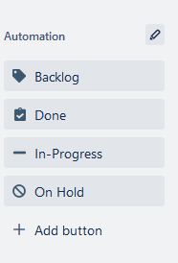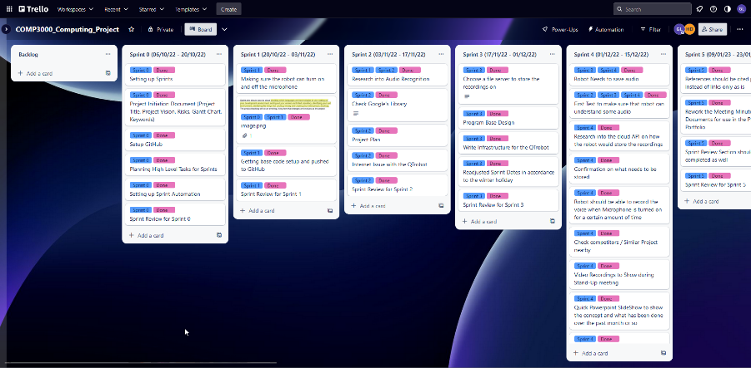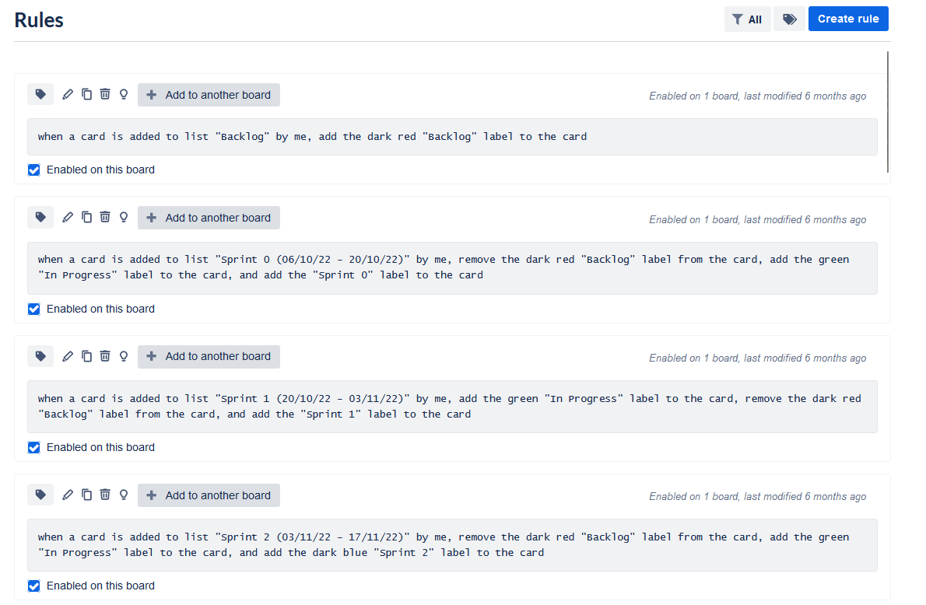

## 5.3 Version Control

A version control is used within this project to keep track of changes within the code. This allows for any accidental deletion of codes if the previous versions of it has been committed and pushed. This also serves as a memory bank to look back at lines of codes or files that have been deleted or changed. With this, the developer is able to look back at which section of the file that could have broken the newer version of the program and revert back to it if needed.

The version control that is being used in this project is GitHub. GitHub is used as it is free to use and it allows for the use of git command line. It is also a big part of this project’s testing phase which will be explained in more detail in the Project Testing section of this report.

* New UML Design after reconsideration

# 6 Project Methodology and Implementation

6.1 Defining an appropriate methodology and discussion of alternatives.

- Show the changes about this, and when and why did it changed.

## 6.1 Project Design / SHOW EARLY DESIGNS OF THE PROJECT BEFORE

- Expectations

- Deviation within the project that might happen

- Talk about skills used in this project

- Implementation of code at appropriate level with demonstration

of good software engineering principles. eg. DRY, YAGNI, SOLID.

WRITE MVP HERE

SHOW CODE HERE THEN.

## 6.2 Skills in Implementation

## 6.3 Deviation in Original Planning in regards to Gantt Chart

## 6.2 Project Testing

Project Testing is done during the development of this project. Testing allows for any changes that needs to be made based on user’s suggestions.

### 6.2.1 User Testing

- Includes the surveys

### 6.2.2 Developer Testing

- During implementation

# 7 Sprint Reviews

This project uses the scrum methodology thus needing sprint reviews. Sprint reviews are used to include what has been completed during the set time, and what the backlog will look like within the next sprint (Wrike, n.d.). Sprints within this project is in two weeks intervals and does not include public holidays, winter vacation and spring vacation. Comparing the dates from the Gantt Chart and the Sprints. There have been some deviations due to some delays that have happened within the project. In total, there are 11 sprints which its dates have been stated below in the review itself.

## 7.1 Sprint 0

Sprint 0 runs from the 6th October till 20th October. The project initiation document (PID) was made that includes the title of the project, project vision, risks, Gantt chart. This initial document will be the basis for the whole project which shows where the project would head in the future and acts as a steppingstone. The GitHub Repository has also been made during this sprint. A Trello board has also been set up to allow for management of tasks and within Trello automations has been set up for automatic labelling.

## 7.2 Sprint 1

Sprint 1 runs from 20th October till 3rd November 2022. During this sprint the QTrobot was checked to make sure that it can turn on and off it’s microphone via the ROS service. The base code was pushed with a template. It was here where there was a Linux GUI issue which did not allow me to run the terminal or any system apps. (Images can be found in the Links section of this document) It was then fix within a week.

## 7.3 Sprint 2

Sprint 2 runs from the 3rd of November 2022 until the 17th November 2022. This sprint went into more research into Audio Recognition. Google’s speech recognition library and Amazon’s Rekognition was also checked accordingly to see which is more suitable for this project. Project Planning for the base designs for the enrolment phase and the recognition phase has been made using draw.io. The internet issue that has been persistent has been fixed during this time.

## 7.4 Sprint 3

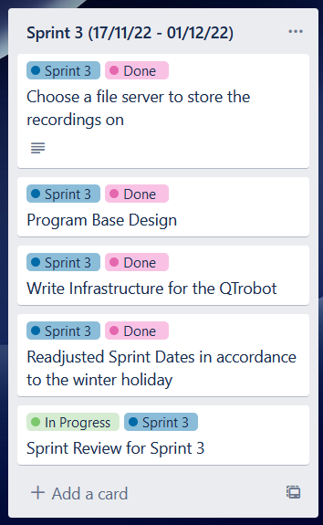

Sprint 3 runs from 17th November 2022 until the 1st December 2022. This sprint consisted of a meeting with Dr Hooman from the University of Hertfordshire on the 18th November. This meeting consisted of information on Visual and Spoken interfaces, Dealing with Voice Biometric. There was talks on Fourier Transformation, Frequency domain and time domains. This meeting helped with the base understanding for Speech Recogntion. S3 by Amazon was chosen as the file server to store the audio recordings. Base first designs were made for the infrastructure section of the report and was written out. Sprint Dates were also readjusted to follow the winter holidays.

## 7.5 Sprint 4

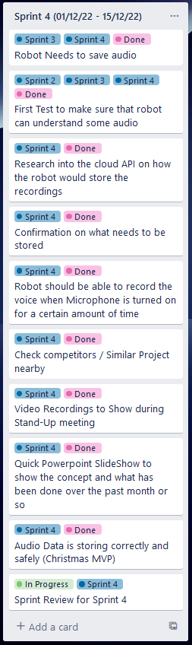

Sprint 4 runs from the 1st of December till the 15th of December 2022. At the end of this sprint, there will be a showcase to the supervisor that shows the progress of what has been done over the past 4 sprints. One of the main developments of the project that can be stated is that the robot is able to save the audio that is recorded. The data is stored locally. Other than that, considerations on what data that is need to be stored has been taken into account. Within the same spectrum, the user would be able to know when they are being recorded. Other competitors and / or similar projects has been checked out and written within this report here. A quick PowerPoint presentation was made up to show the concept that has been done as well. The PowerPoint presentation can be found over [here](https://liveplymouthac-my.sharepoint.com/:p:/r/personal/gregory_kua_students_plymouth_ac_uk/Documents/Year%203%20(Stage%204)/COMP3000%20Computing%20Project%20(22AYAUM)/Submissions/Final_Submission_COMP3000_GregoryKua/MVP%20Folder%20(Including%20Video%20Footage)/MVP_3.pptx?d=w5b47efffb8244b78b2f723cc2345f623&csf=1&web=1&e=nIbkaq).

## 7.6 Sprint 5

Sprint 5 runs from 9th January to 23rd January. Documentation has been updated during this sprint. Meeting Minutes has been reworked to be easier to read and to prepare for insertion within the documentation. References has been reworked to follow Harvard referencing instead of short links. There has been no major development to this project due to other modules taking over most of the time. Main heading for Sprint Review section has been written out here as well.

## 7.7 Sprint 6

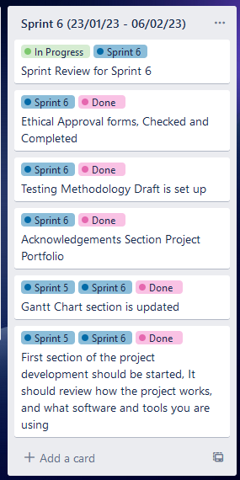

Sprint 6 runs from 23rd January to 6th February. This sprint, Ethical approval forms have been checked. Document has been updated with more hyperlinks and have surpassed 2000 words within this sprint.

## 7.8 Sprint 7

Sprint 7 runs from 6th February to 20th February. During this sprint, plans for downscaling the project was made here. This is due to the fact that there were some unknown issues with boto3’s API. This caused some inconsistency on when it will run. Timeline from here on out has been affected slightly.

## 7.9 Sprint 8

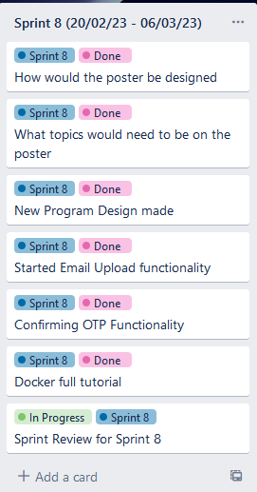

Sprint 8 runs from 20th February till 6th March. During this sprint, the poster designs were started to be made. This includes with checking what topics and text would need to be on the poster. This is for the March submission. Next, program designs were made as well. Email uploading functionality have been started. OTP (One Time Passcode) functionality has also been implemented. During this sprint, the developer decided to learn docker in full to make development easier.

## 7.10 Sprint 9

Sprint 9 runs from the 6th of March to 20th March. With this sprint, the database server (PostgreSQL) is made and tested. The email server was then put and set up but due to some issues the self hosted email server was than not used within the project after this. Project Vision was then updated with the new changes to the project that was done. Finally, for the next submission there was a poster deadline and the template for it was started.

## 7.11 Sprint 10

Sprint 10 was a short sprint due to the deadlines for the other modules that the author was taking. The poster was completed and submitted on time. The description for the website and the poster was also written down and uploaded to the DLE on time. This report was then sent in for checks during this sprint.

## 7.12 Sprint 11

# 7 Critical Evaluation

* Results of the software that has been made]
* Accuracy of the library

# 8 Evaluation (Discussion of Deviation, Big Changes)

## 8.1 Sprints Evaluation

## 8.2 Post Evaluation

- Have user stories been achieved?

# 9 Reflection

# 10 Conclusion

# 11 References

*ACM Code of Ethics and Professional Conduct* (n.d.) *Code of Ethics*. ACM. Available at: https://www.acm.org/code-of-ethics.

*BCS Code of conduct* (n.d.) *BCS*. BCS. Available at: https://www.bcs.org/membership-and-registrations/become-a-member/bcs-code-of-conduct/.

Google (n.d.) *Teach google assistant to recognize your voice with voice match - android*, *Google Assistant Help*. Google. Available at: <https://support.google.com/assistant/answer/9071681#vm_pr&zippy=%2Cvoice-match-personal-results>.

*Guide to the UK General Data Protection Regulation (UK GDPR)* (n.d.) *ICO*. Available at: https://ico.org.uk/for-organisations/guide-to-data-protection/guide-to-the-general-data-protection-regulation-gdpr/.

HSBC (n.d.) *Telephone banking: Give our friendly team A call - HSBC UK*, *Telephone Banking | Give Our Friendly Team a Call - HSBC UK*. HSBC. Available at: <https://www.hsbc.co.uk/ways-to-bank/phone-banking/>.

Lewicki, P., Tochowicz, J. and van Genuchten, J. (2019) “Are robots taking our jobs? A RoboPlatform at a bank,” *IEEE Software*, 36(3), pp. 101–104. Available at: https://doi.org/10.1109/ms.2019.2897337.

Microsoft (n.d.) *Use voice recognition in Windows*, *Microsoft Support*. Microsoft. Available at: https://support.microsoft.com/en-gb/windows/use-voice-recognition-in-windows-83ff75bd-63eb-0b6c-18d4-6fae94050571.

Microsoft (n.d.) *Windows Speech Recognition commands*, *Microsoft Support*. Microsoft. Available at: https://support.microsoft.com/en-gb/windows/windows-speech-recognition-commands-9d25ef36-994d-f367-a81a-a326160128c7#WindowsVersion=Windows_11.

*QTrobot, an engaging educational robot for children with autism and special needs education* (2022) *LuxAI S.A.* LuxAI. Available at: https://luxai.com/robot-for-teaching-children-with-autism-at-home/.

*QTrobot documentation* (n.d.) *QTrobot Documentation*. Available at: <https://docs.luxai.com/>.

*Privacy-preserving Robotics in DEntistry (PRiDE)* (n.d.) *Privacy-preserving Robotics in DEntistry*. University of Plymouth. Available at: https://www.plymouth.ac.uk/research/privacy-preserving-robotics-in-dentistry.

Rehkopf, M. (n.d.) *What is a Kanban Board?*, *Atlassian*. Available at: https://www.atlassian.com/agile/kanban/boards.

*Robot operating system* (n.d.) *ROS*. Available at: https://www.ros.org/.

*The principles* (n.d.) *ICO*. Available at: https://ico.org.uk/for-organisations/guide-to-data-protection/guide-to-the-general-data-protection-regulation-gdpr/principles/.

*Trello for product management teams* (n.d.) *Trello*. Available at: <https://trello.com/teams/product>.

*What are user stories?* (n.d.) *Agile Alliance |*. Available at: https://www.agilealliance.org/glossary/user-stories/.

# 12 Appendix